**PRACTICAL-4**

**AIM: Indexing ,Aggregation and Map Reduce in NoSQL-DB.**

1. **PRACTICE QUESTIONS:**

**1. Indexing :- Query :- for( var iCounter=1;iCounter<= 1000000;iCounter++)**

**{ db.Asset.insert(**

**{**

**"Name":"Voting"+iCounter,**

**"Desc":"Story about a college student"+iCounter,**

**"Rank":iCounter,**

**"Language":["English","Hindi","Tamil"],**

**"AssetGrp":[ { "GrpName":"16+", "Desc":" Can be admitted in college**

**16+ years old"+iCounter } ]**

**})**

**}**

**Output :-**

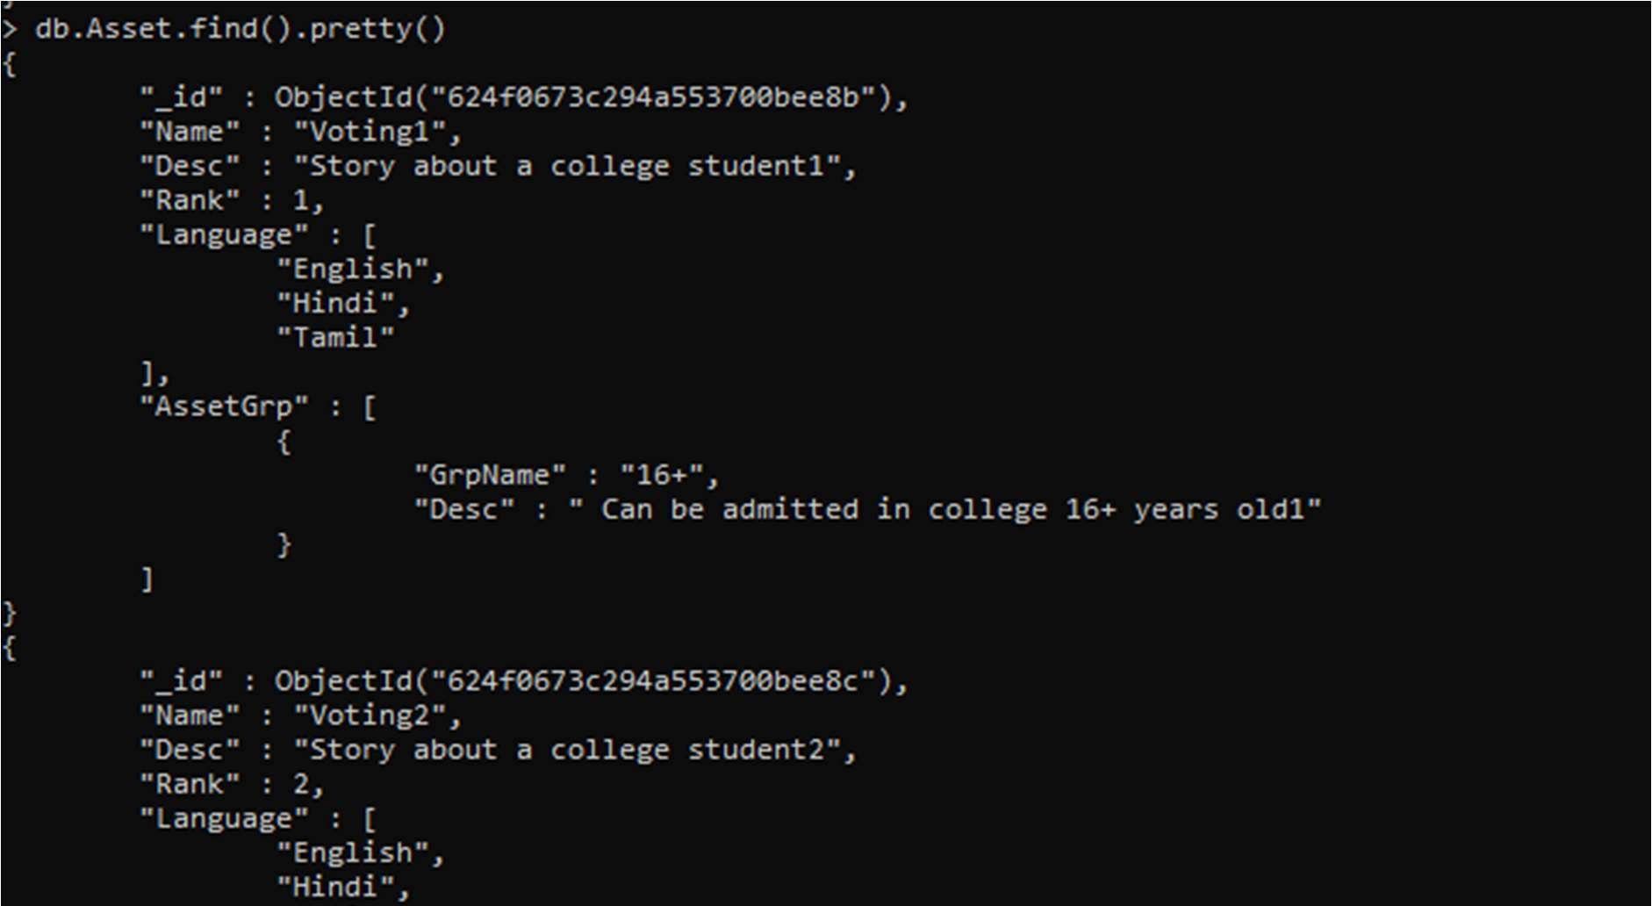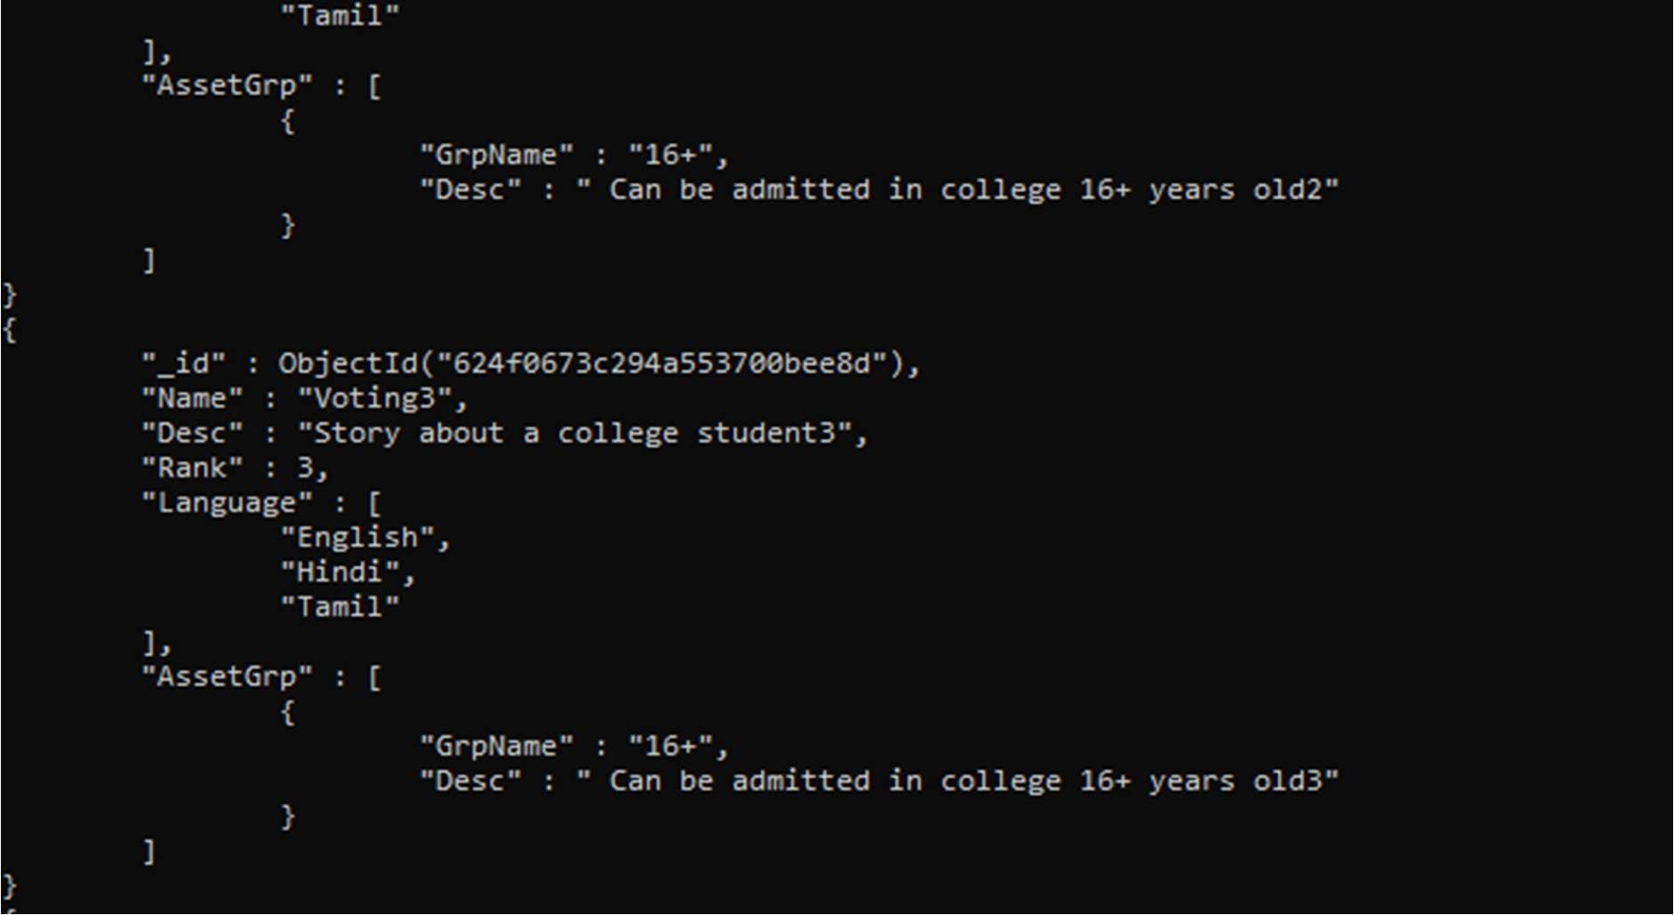

2. Aggregation :-

➢ Ex-1 : Create collection name as “gnu”

Add 10 relevant documents in same collection. Query :- db.gnu.aggregate([{$group : {_id : "$by_user", num_tutorial : {$sum : 1}}}]) Output :-

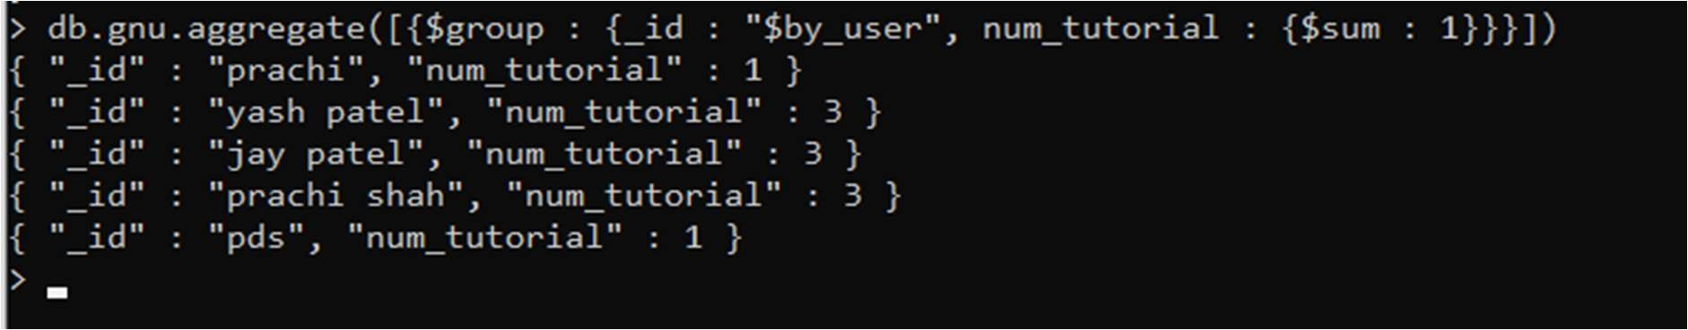

Query:- db.gnu.aggregate([{$group:{_id:"$by_user",sum:{$sum:"$likes"}}}]) Output :-

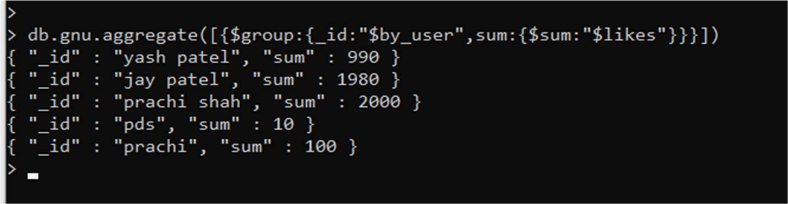

Query :- db.gnu.aggregate([{$group:{_id:"$by_user",avg:{$avg:"$likes"}}}]) Output :-

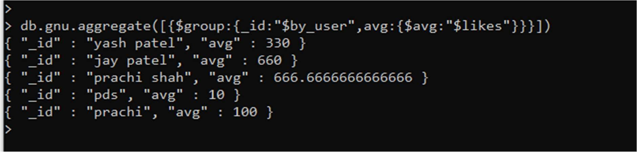

Query :- db.gnu.aggregate([{$group:{_id:"$by_user",min:{$min:"$likes"}}}])

Output :-

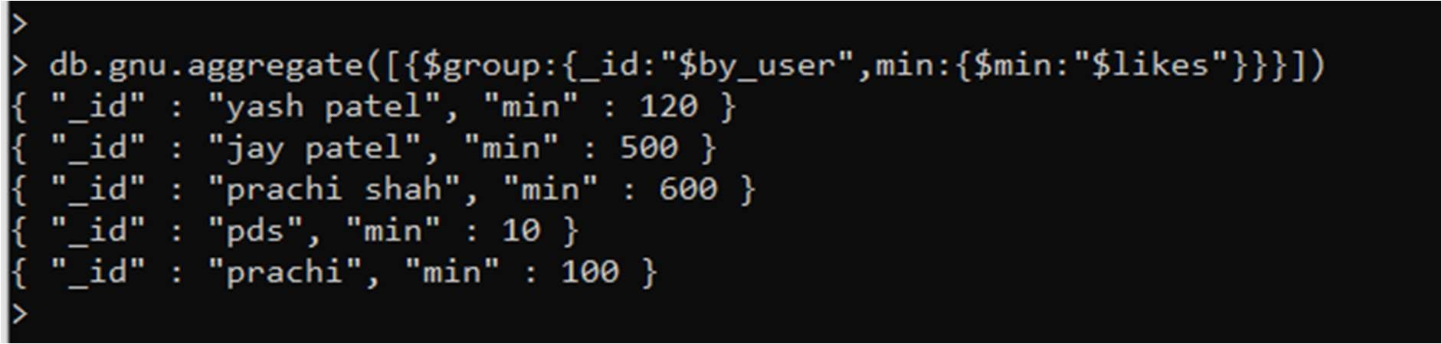

Query :- db.gnu.aggregate([{$group:{_id:"$by_user",max:{$max:"$likes"}}}]) Output :-

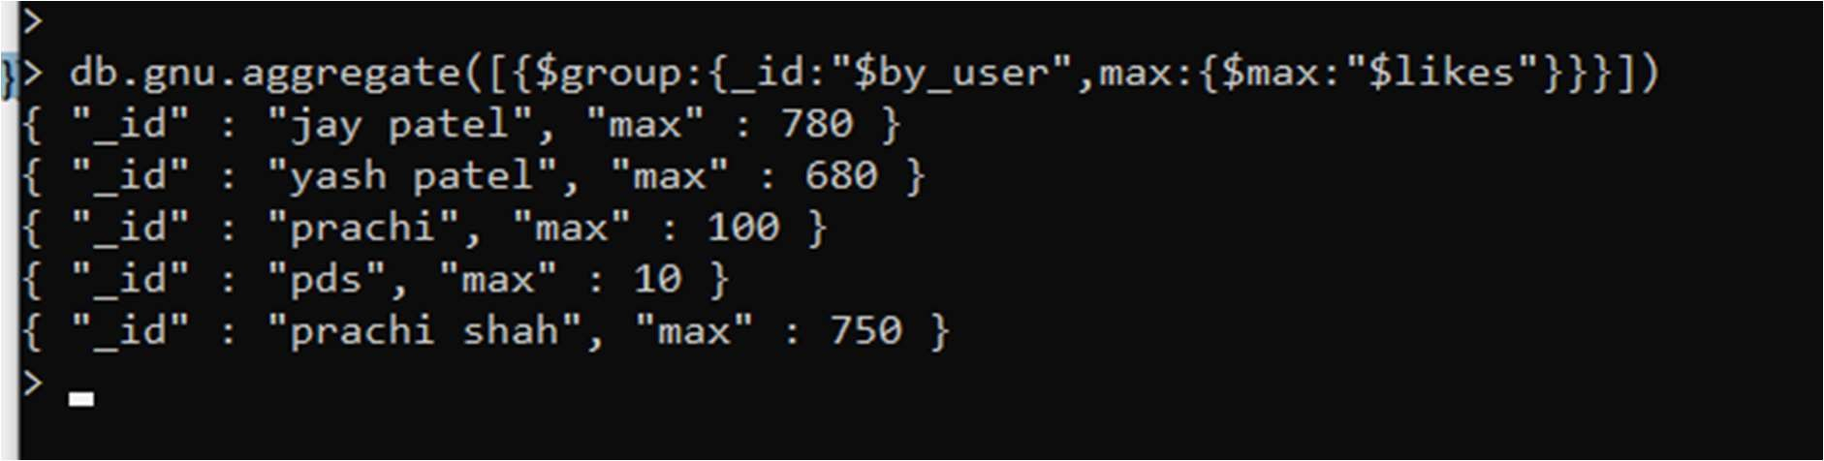

Query :- db.gnu. aggregate([{$group:{_id:"$by_user",first_url:{$first:"$url"}}}]) Output :-

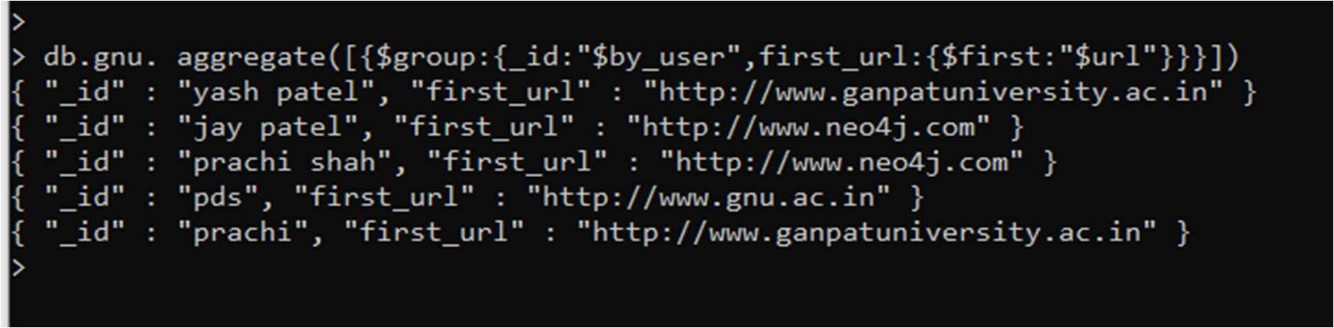

Query :- db.gnu.aggregate([{$group:{_id:"$by_user",last_url:{$last:"$url"}}}])

Output :-

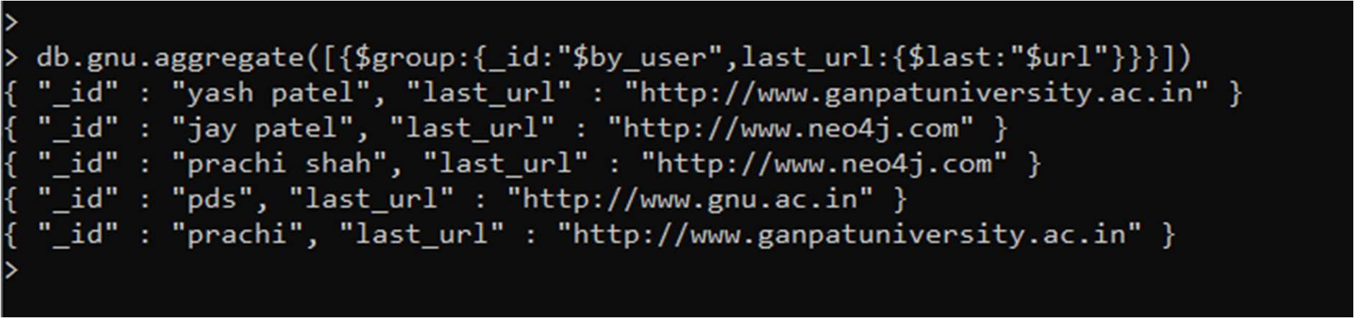

➢ EX-2 :

Create a collection called purchase_orders having fildes product (toothbrush , guitar , milk , pizza ) , price , customer_name insert 10 records into collections.

• Query: -

1. find out how many toothbrushes were sold. Query: - db.purchase_order.find({"product":"Toothbrush"}).count() Output :-

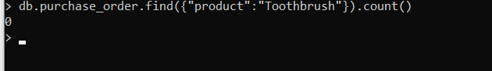

1. find the list of all products sold. Query: - db.purchase_order.distinct("product")

Output :-

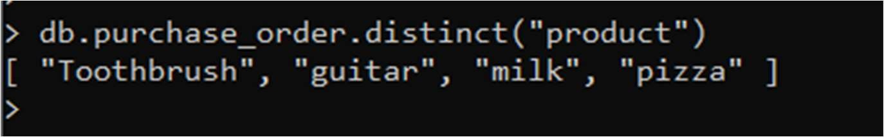

1. find the total amount of money spent by each customer. Query: - db.purchase_order.aggregate([{$group :{_id:"$customername",total:{$sum:"$price"}}}])

Output :-

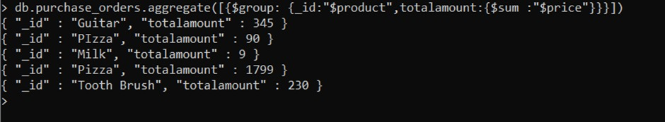

1. find the total amount of money spent on each product. Query: - db.purchase_order.aggregate([{$group :{_id:"$product",total:{$sum:"$price"}}}]) Output :-

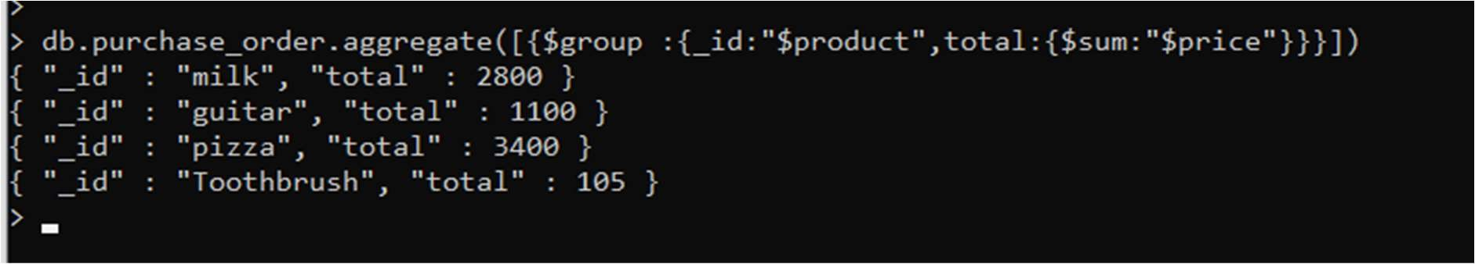

1. find how much money each customer has spent on toothbrushes or pizza. Query: -

db.purchase_order.aggregate([{$match:{$or:[{"product":"pizza"},{"product":"Toothbrush"}] }},{$group:{_id:"$customername",spent:{$sum:"$price"}}}])

Output :-



1. calc. the avg purchase price of ABC. Query: -

db.purchase_order.aggregate([{$group : {_id:"null",total:{$avg:"$price"}}}]) Output :-

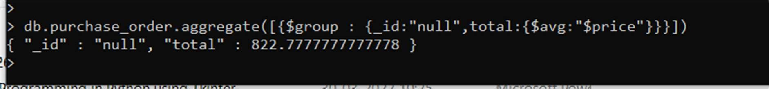

➢ EX-3:

create a collection called employee having fields name, department(Admin,ce,it,hr) , age , total_exp, languages(diff languages) insert 8 records into collections

• Queries:-

1. find the total age of employees for each department.

Query:- db.emp.aggregate([{$group : {_id:"$department",age_sum:{$sum:"$age"}}}]) Output :- 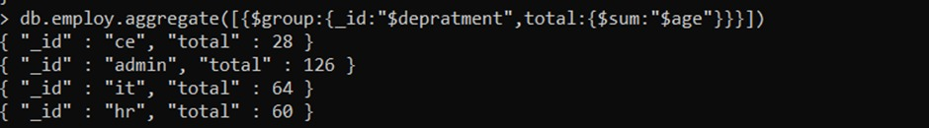

1. calc. the avg experience of each department. Query:- db.emp.aggregate([{$group : {_id:"$department",avgexp:{$avg:"$exp"}}}]) Output :-

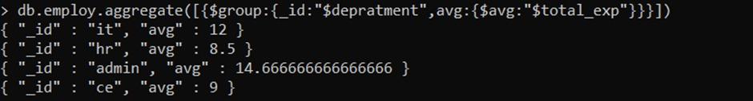

1. find the youngest and oldest employee. Query:-

db.emp.aggregate([{$group:{_id:null,youngest_emp: {$min:"$age"},oldest_emp:{$max:"$age"}}}])

Output :-



1. find the minimum and maximum experienced employee from department admin.

Query:- db.emp.aggregate([{$match:{"department":"admin"}},{$group:{_id:null,min_total_exp:{$mi n:"$total_exp"},max_total_exp:{$max:"$total_exp"}}}]) Output :-



3. Map-Reduce :-

➢ Ex-1:

create a collection called car having fields car_id, name, color, car_number, mfd_country, speed and price insert 8 records

create a map function that will get data of cars having speeds greater than 70 create a reduce function that will find the average speed code :- var map1=function(){ if(this.speed>70){ emit(this.car_id,this.speed);

} }; var reduce=function(car_id,speed){ var a=Array.avg(speed); return a;

};

Query :- db.car.mapReduce(map,reduce1,{out:{inline:1}}) Output :- 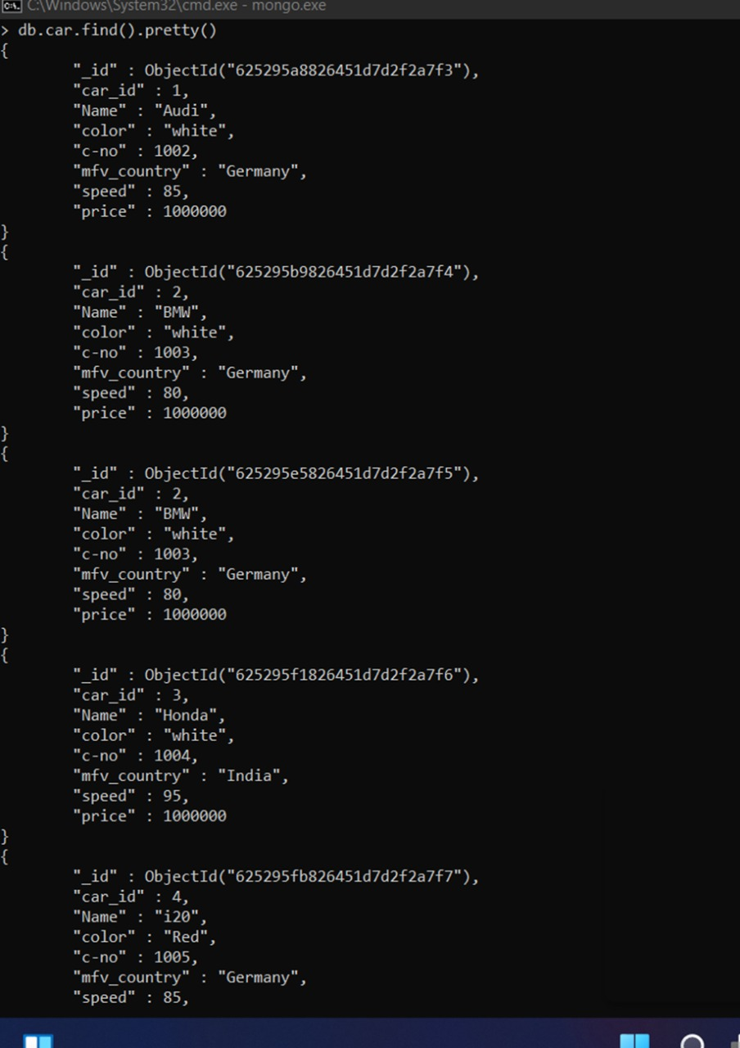

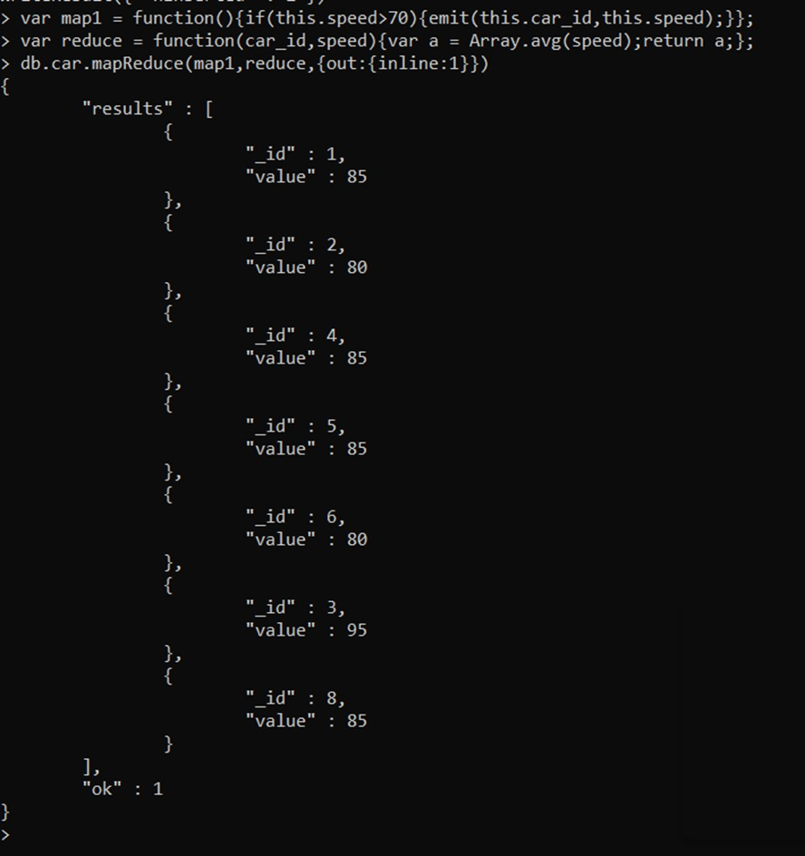

➢ Ex-2:

create a collection called city having two fields city(Ahemdabad, Mehsana,

Baroda) and Temperature.

insert 8 records

Output :-

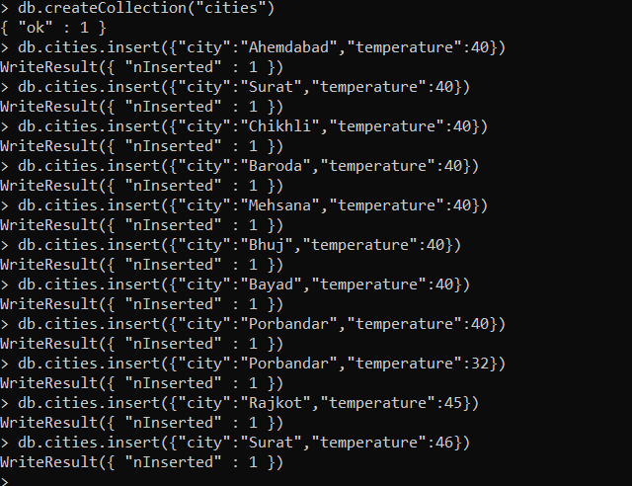

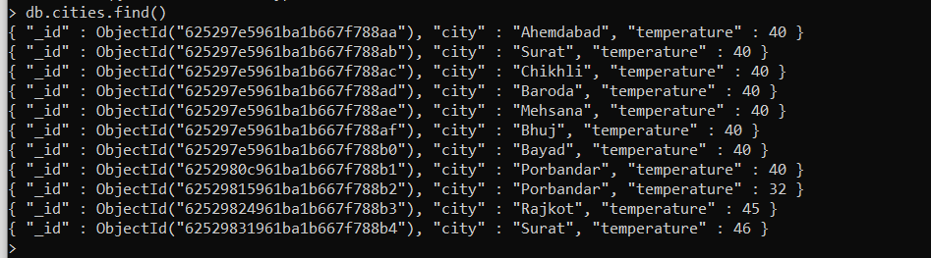

create a map and reduce function to find maximum temperature for each city.

var map=function(){ emit(this.city,this.tempereture)

}; var maxt=function(city, tempereture){ var max= tempereture [0]; for(var i=0;i< tempereture.length;i++){ if(tempereture [i]>max){ max= tempereture [i];

} return max;

} }; var mint=function(city, tempereture){

var min= tempereture [0]; for(var i=0;i< tempereture.length;i++){ if(tempereture [i]<min){ min= tempereture [i];

} return min;

}

};

Query:

db.city.mapReduce(map,mint,{out:{inline:1}})

Output :-

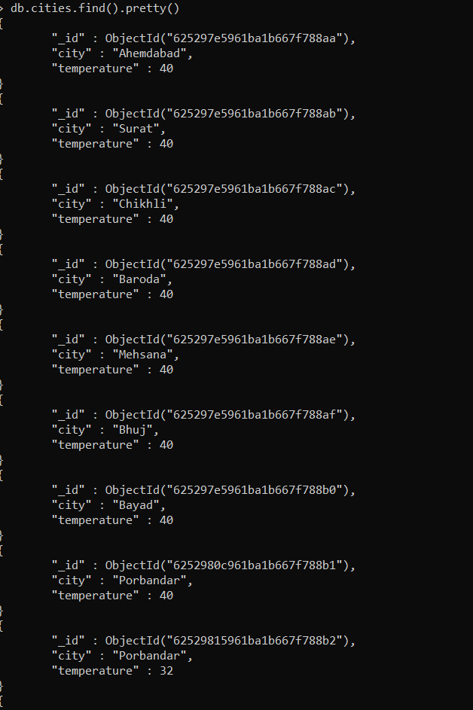

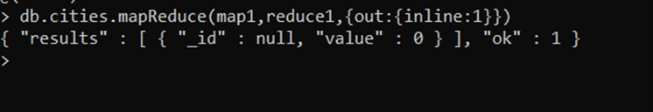

➢ Ex-3 : create a collection called AB3 having fields student_names,subject and marks.

insert 8 records

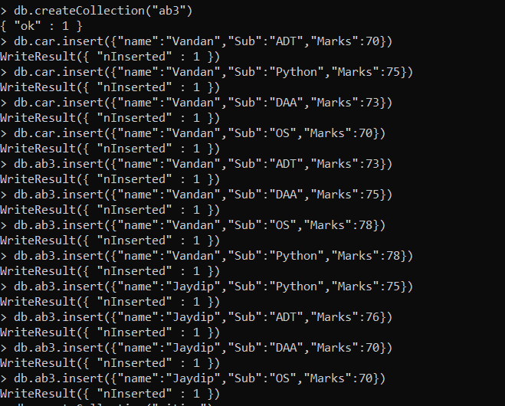

Output :

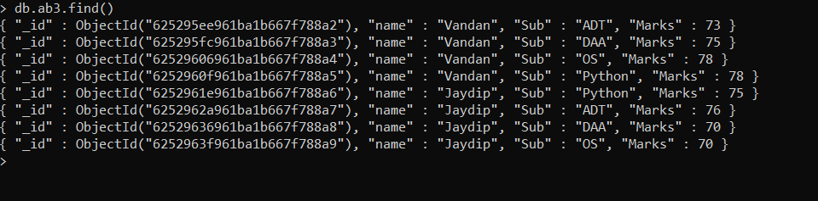

create map and reduce function to get total marks for each student and output should be written in collection name total.

db.ab3.find() db.createCollection("Hello")

var map=function(){ emit(this.name,this.marks)

};

var red=function(name,marks){

var sum=0; for(var i=0;i<marks.length;i++){ sum=sum+marks[i];

} return sum;

}

Query:

db.ab3.mapReduce(map,red,{out:"Hello"}) db.Hello.find()

Output :-

